Berikut ini contoh penggunaan pillow untuk membaca dan memisahkan channel RGB
- Membaca dan menampilkan citra
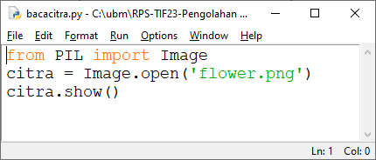
Ketik dan run program di atas
Source Code:
from PIL import Image
citra = Image.open('flower.png')
citra.show()
Hasil Screenshot:
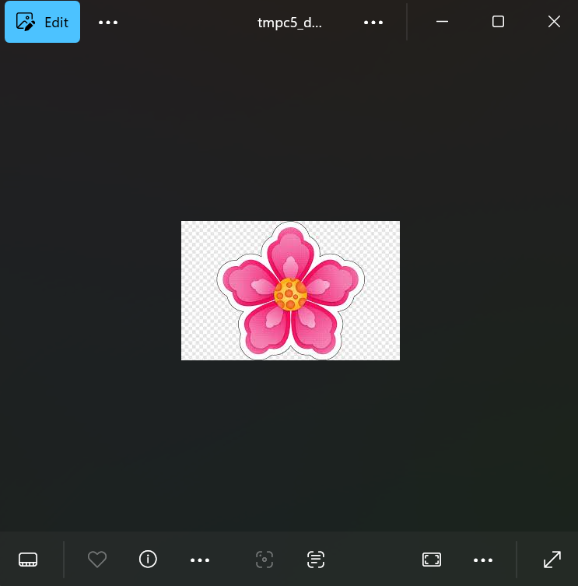

- Memisahkan channel R, G dan B
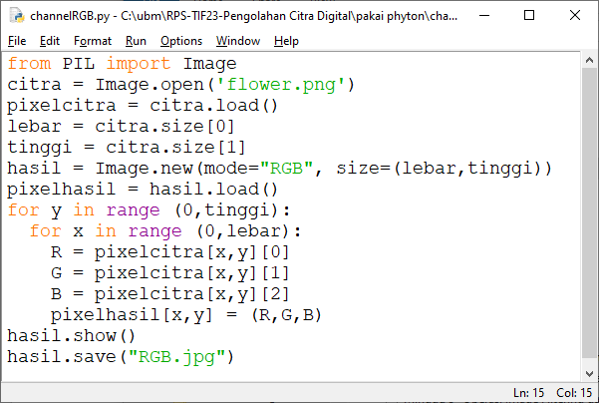
Ketik dan Run Program di atas
Source Code:
from PIL import Image
citra = Image.open('flower.png')
pixelcitra = citra.load()
lebar = citra.size[0]
tinggi = citra.size[1]
hasil = Image.new (mode = "RGB", size = (lebar, tinggi))
pixelhasil = hasil.load()
for y in range (0, tinggi):
for x in range (0, lebar):
R = pixelcitra[x, y] [0]
G = pixelcitra[x, y] [1]
B = pixelcitra[x, y] [2]
pixelhasil[x, y] = (R, G, B)
hasil.show()
hasil.save("RGB.jpg")

Hasil Screenshot:
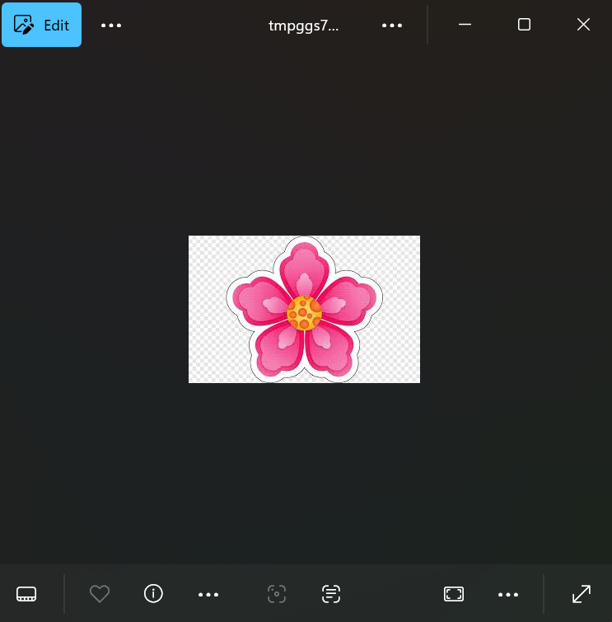
- Menampilkan channel R saja
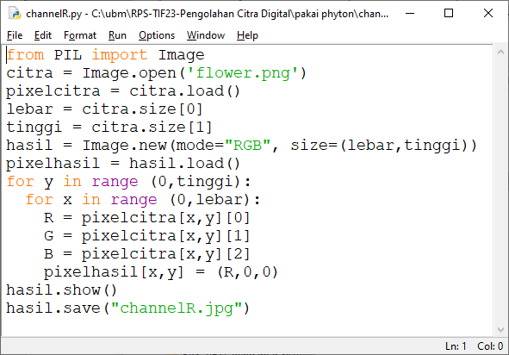

Source Code:
from PIL import Image
citra = Image.open('flower.png')
pixelcitra = citra.load()
lebar = citra.size[0]
tinggi = citra.size[1]
hasil = Image.new (mode = "RGB", size = (lebar, tinggi))
pixelhasil = hasil.load()
for y in range (0, tinggi):
for x in range (0, lebar):
R = pixelcitra[x, y] [0]
G = pixelcitra[x, y] [1]
B = pixelcitra[x, y] [2]
pixelhasil[x, y] = (R, 0, 0)
hasil.show()
hasil.save("channelR.jpg")
Hasil Screenshot:

3a. Buatlah program untuk menampilkan channel G saja
Source Code:
from PIL import Image
citra = Image.open('flower.png')
pixelcitra = citra.load()
lebar = citra.size[0]
tinggi = citra.size[1]
hasil = Image.new (mode = "RGB", size = (lebar, tinggi))
pixelhasil = hasil.load()
for y in range (0, tinggi):
for x in range (0, lebar):
R = pixelcitra[x, y] [0]
G = pixelcitra[x, y] [1]
B = pixelcitra[x, y] [2]
pixelhasil[x, y] = (0, G, 0)
hasil.show()
hasil.save("channelG.jpg")
Hasil Screenshot:

3.b buatlah program untuk menampilkan channel B saja
Source Code:
from PIL import Image
citra = Image.open('flower.png')
pixelcitra = citra.load()
lebar = citra.size[0]
tinggi = citra.size[1]
hasil = Image.new (mode = "RGB", size = (lebar, tinggi))
pixelhasil = hasil.load()
for y in range (0, tinggi):
for x in range (0, lebar):
R = pixelcitra[x, y] [0]
G = pixelcitra[x, y] [1]
B = pixelcitra[x, y] [2]
pixelhasil[x, y] = (0, 0, B)
hasil.show()
hasil.save("channelB.jpg")
Hasil Screenshot:
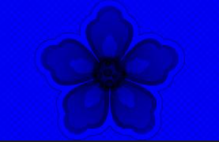

3.c buatlah program untuk menampilkan channel R dan G
Source Code:
from PIL import Image
citra = Image.open('flower.png')
pixelcitra = citra.load()
lebar = citra.size[0]
tinggi = citra.size[1]
hasil = Image.new (mode = "RGB", size = (lebar, tinggi))
pixelhasil = hasil.load()
for y in range (0, tinggi):
for x in range (0, lebar):
R = pixelcitra[x, y] [0]
G = pixelcitra[x, y] [1]
B = pixelcitra[x, y] [2]
pixelhasil[x, y] = (R, G, 0)
hasil.show()
hasil.save("channelRnG.jpg")
Hasil Screenshot:
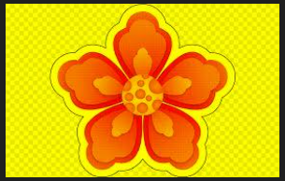
3.d buatlah program untuk menampilkan channel G dan B
Source Code:
from PIL import Image
citra = Image.open('flower.png')
pixelcitra = citra.load()
lebar = citra.size[0]
tinggi = citra.size[1]
hasil = Image.new (mode = "RGB", size = (lebar, tinggi))
pixelhasil = hasil.load()
for y in range (0, tinggi):
for x in range (0, lebar):
R = pixelcitra[x, y] [0]
G = pixelcitra[x, y] [1]
B = pixelcitra[x, y] [2]
pixelhasil[x, y] = (0, G, B)
hasil.show()
hasil.save("channelGnB.jpg")
Hasil Screenshot:

3.e buatlah program untuk menampilkan channel R dan B
Source Code:
from PIL import Image
citra = Image.open('flower.png')
pixelcitra = citra.load()
lebar = citra.size[0]
tinggi = citra.size[1]
hasil = Image.new (mode = "RGB", size = (lebar, tinggi))
pixelhasil = hasil.load()
for y in range (0, tinggi):
for x in range (0, lebar):
R = pixelcitra[x, y] [0]
G = pixelcitra[x, y] [1]
B = pixelcitra[x, y] [2]
pixelhasil[x, y] = (R, 0, B)
hasil.show()
hasil.save("channelRnB.jpg")
Hasil Screenshot:
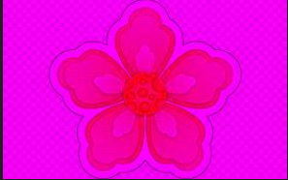

- Citra Grayscale
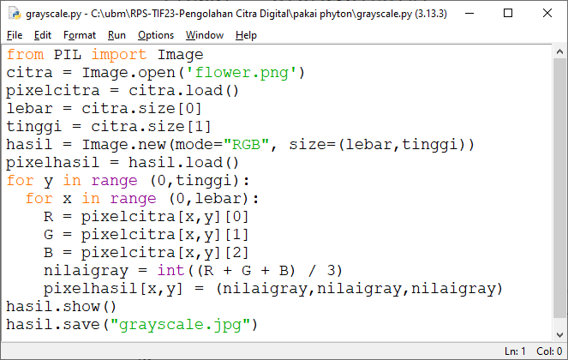
Ketik dan run program di atas
Source Code:
from PIL import Image
citra = Image.open('flower.png')
pixelcitra = citra.load()
lebar = citra.size[0]
tinggi = citra.size[1]
hasil = Image.new (mode = "RGB", size = (lebar, tinggi))
pixelhasil = hasil.load()
for y in range (0, tinggi):
for x in range (0, lebar):
R = pixelcitra[x, y] [0]
G = pixelcitra[x, y] [1]
B = pixelcitra[x, y] [2]
nilaigray = int ((R + G + B) / 3)
pixelhasil[x, y] = (nilaigray, nilaigray, nilaigray)
hasil.show()
hasil.save("grayscale.jpg")

Hasil Screenshot:
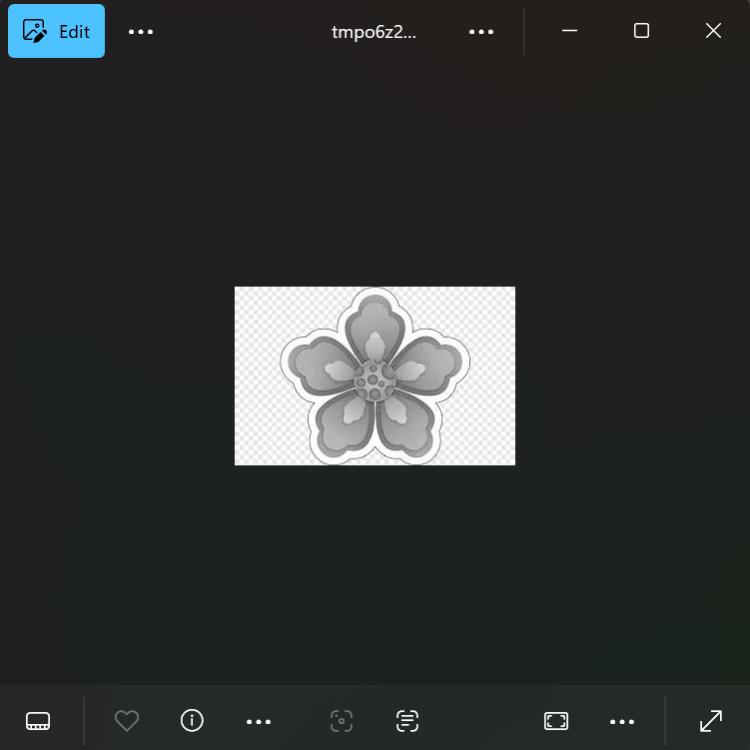
- Monochrome
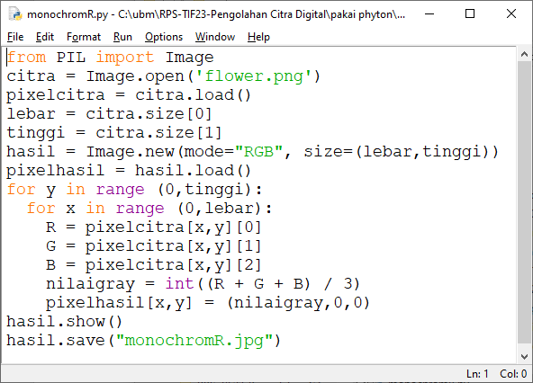
Contoh monochrome R
Source Code:
from PIL import Image
citra = Image.open('flower.png')
pixelcitra = citra.load()
lebar = citra.size[0]
tinggi = citra.size[1]
hasil = Image.new (mode = "RGB", size = (lebar, tinggi))
pixelhasil = hasil.load()
for y in range (0, tinggi):
for x in range (0, lebar):
R = pixelcitra[x, y] [0]
G = pixelcitra[x, y] [1]
B = pixelcitra[x, y] [2]
nilaigray = int ((R + G + B) / 3)
pixelhasil[x, y] = (nilaigray, 0, 0)
hasil.show()
hasil.save("monochromeR.jpg")
Hasil Screenshot:
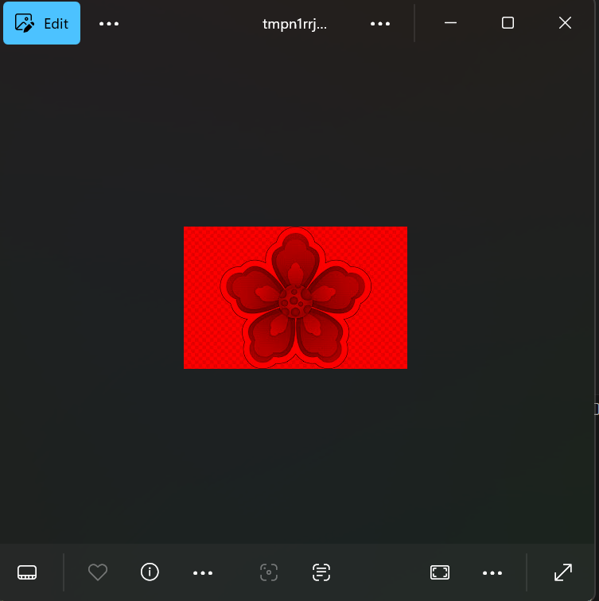
5.a. buatlah program untuk menampilkan monchrome G
Source Code:
from PIL import Image
citra = Image.open('flower.png')
pixelcitra = citra.load()
lebar = citra.size[0]
tinggi = citra.size[1]
hasil = Image.new (mode = "RGB", size = (lebar, tinggi))
pixelhasil = hasil.load()
for y in range (0, tinggi):
for x in range (0, lebar):
R = pixelcitra[x, y] [0]
G = pixelcitra[x, y] [1]
B = pixelcitra[x, y] [2]
nilaigray = int ((R + G + B) / 3)
pixelhasil[x, y] = (0, nilaigray, 0)
hasil.show()
hasil.save("monochromeG.jpg")
Hasil Screenshot:
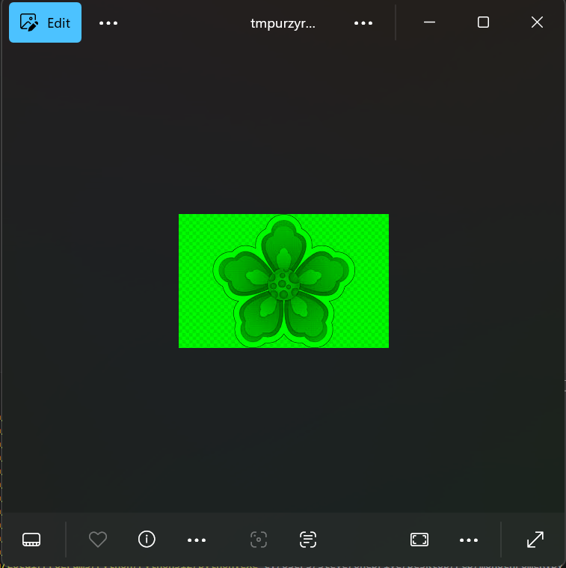
5.b. buatlah program untuk menampilkan monchrome B
Source Code:
from PIL import Image
citra = Image.open('flower.png')
pixelcitra = citra.load()
lebar = citra.size[0]
tinggi = citra.size[1]
hasil = Image.new (mode = "RGB", size = (lebar, tinggi))
pixelhasil = hasil.load()
for y in range (0, tinggi):
for x in range (0, lebar):
R = pixelcitra[x, y] [0]
G = pixelcitra[x, y] [1]
B = pixelcitra[x, y] [2]
nilaigray = int ((R + G + B) / 3)
pixelhasil[x, y] = (0, 0, nilaigray)
hasil.show()
hasil.save("monochromeB.jpg")

Hasil Screenshot:
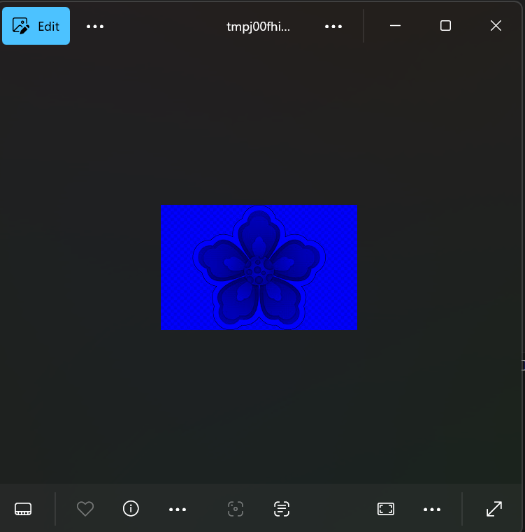
5.c. buatlah program untuk menampilkan monchrome R dan G
Source Code:
from PIL import Image
citra = Image.open('flower.png')
pixelcitra = citra.load()
lebar = citra.size[0]
tinggi = citra.size[1]
hasil = Image.new (mode = "RGB", size = (lebar, tinggi))
pixelhasil = hasil.load()
for y in range (0, tinggi):
for x in range (0, lebar):
R = pixelcitra[x, y] [0]
G = pixelcitra[x, y] [1]
B = pixelcitra[x, y] [2]
nilaigray = int ((R + G + B) / 3)
pixelhasil[x, y] = (nilaigray, nilaigray, 0)
hasil.show()
hasil.save("monochromeRnG.jpg")

Hasil Screenshot:
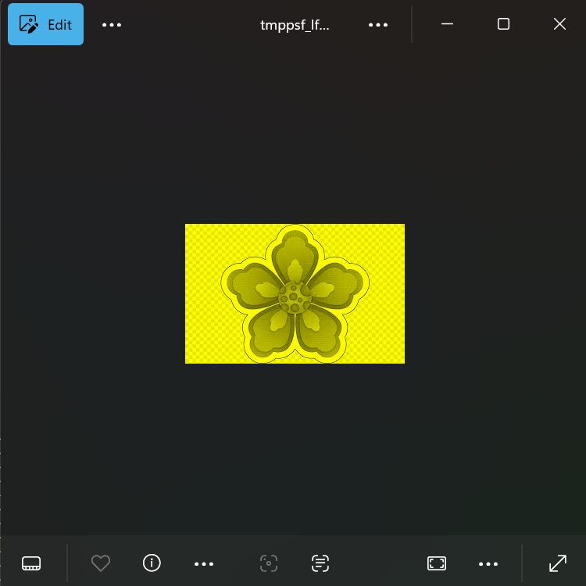
5.d. buatlah program untuk menampilkan monchrome G dan B
Source Code:
from PIL import Image
citra = Image.open('flower.png')
pixelcitra = citra.load()
lebar = citra.size[0]
tinggi = citra.size[1]
hasil = Image.new (mode = "RGB", size = (lebar, tinggi))
pixelhasil = hasil.load()
for y in range (0, tinggi):
for x in range (0, lebar):
R = pixelcitra[x, y] [0]
G = pixelcitra[x, y] [1]
B = pixelcitra[x, y] [2]
nilaigray = int ((R + G + B) / 3)
pixelhasil[x, y] = (0, nilaigray, nilaigray)
hasil.show()
hasil.save("monochromeGnB.jpg")

Hasil Screenshot:
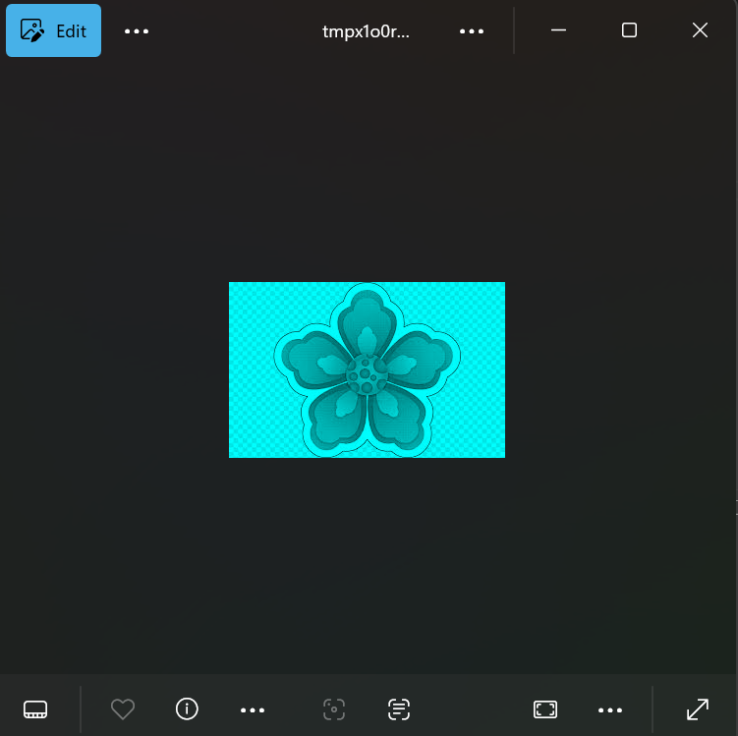

5.e. buatlah program untuk menampilkan monchrome R dan B
Source Code:
from PIL import Image
citra = Image.open('flower.png')
pixelcitra = citra.load()
lebar = citra.size[0]
tinggi = citra.size[1]
hasil = Image.new (mode = "RGB", size = (lebar, tinggi))
pixelhasil = hasil.load()
for y in range (0, tinggi):
for x in range (0, lebar):
R = pixelcitra[x, y] [0]
G = pixelcitra[x, y] [1]
B = pixelcitra[x, y] [2]
nilaigray = int ((R + G + B) / 3)
pixelhasil[x, y] = (nilaigray, 0, nilaigray)
hasil.show()
hasil.save("monochromeRnB.jpg")

Hasil Screenshot:
